# C3- S7 PRACTICE

# Ex 1: Can I go to PNC?

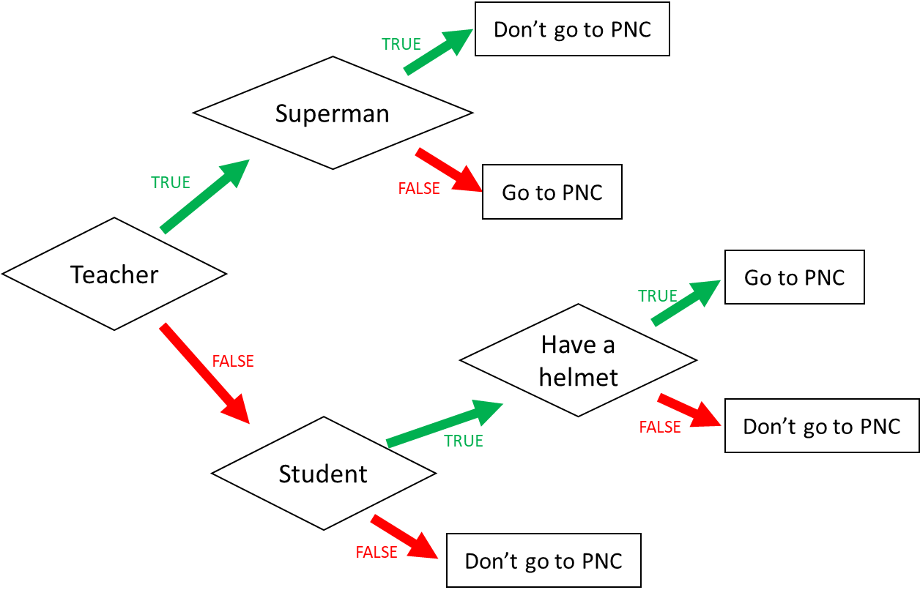

1. I am a teacher and I am superman, can I go to PNC? No, I can not.(Don’t go to PNC)
2. I am not a teacher and not a student, can I go to PNC?No, I can not.(don’t go to pnc)
3. When can I go to PNC? (Express the condition using a Boolean expression)

I go to PNC if:

( teacher and not superman) or (not teacher and student and have a helmet)

Ex 2: What do I eat?

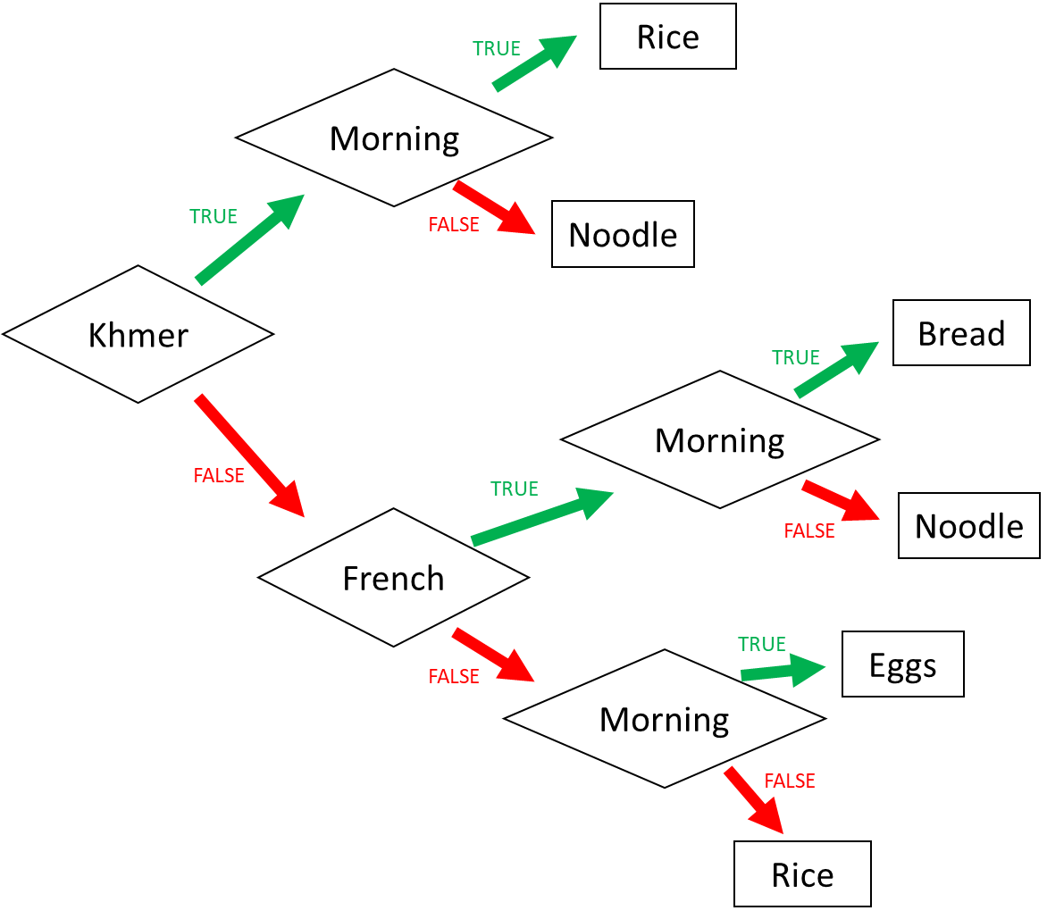

1. I am Khmer and it is the evening. What do I eat? Noodle

2. I am French and it is the morning. What do I eat? Bread

3. I am American and it is the morning. What do I eat? Eggs

4. When do I eat rice? (Express the condition using a Boolean expression)

I eat rice if:

(Khmer and Morning) or (not Khmer and Not French and not Morning)

Ex 3: Do I go to the pool?

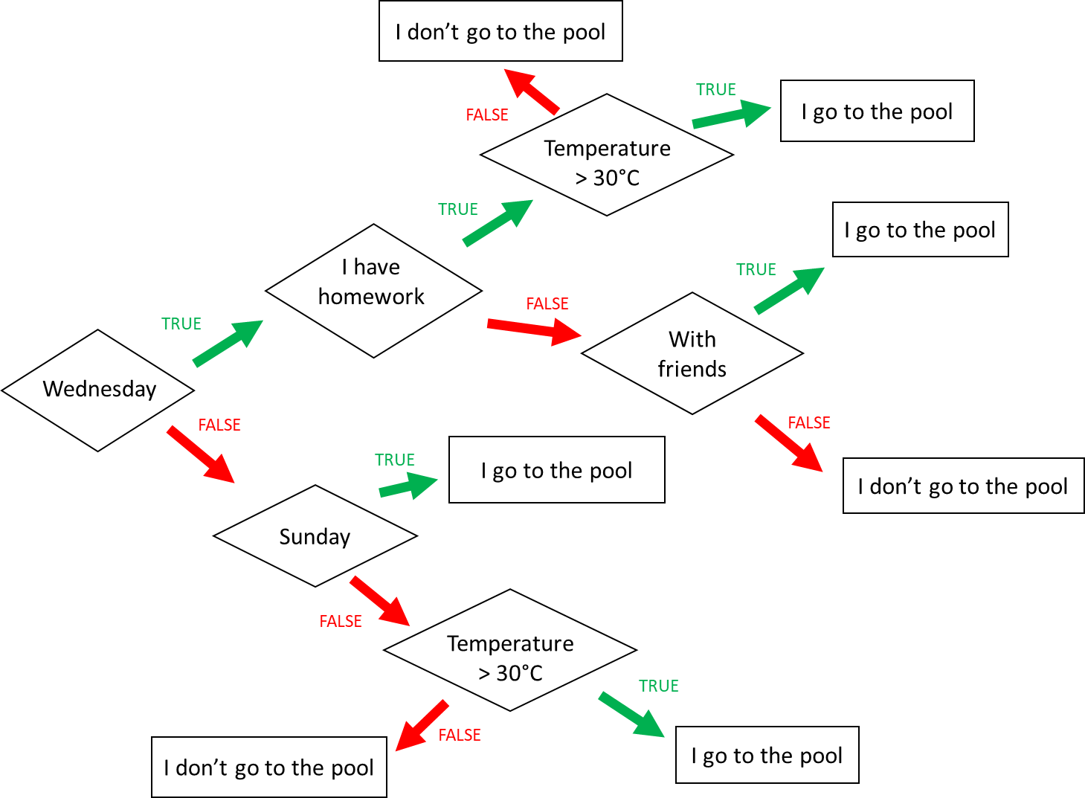

**Input 1 :**

* Wednesday
* Temperature = 31°C
* **Homework**

🡪 Do I go to the pool ?

You, I do. I go the pool.

**Input 2 :**

* Monday
* Temperature = 35°C
* I have no friend

🡪 Do I go to the pool ?

Yes, I do. I go to the pool.

**Input 3 :**

* Wednesday
* I have **no** homework
* I’m with friends
* Temperature = 28°C

🡪 Do I go to the pool ?

Yes, I do.I go the pool.

When do I go to the pool ? (Express the condition using a Boolean expression)

I go to the pool if :

(wenesday and I have homework and temperature>30c) or (wenesday and not homework and with friends) or (not Wenesday and Sunday) or ( not Wenesday and not Sunday and temperature>30c)

Ex4: Do I create a Facebook account?

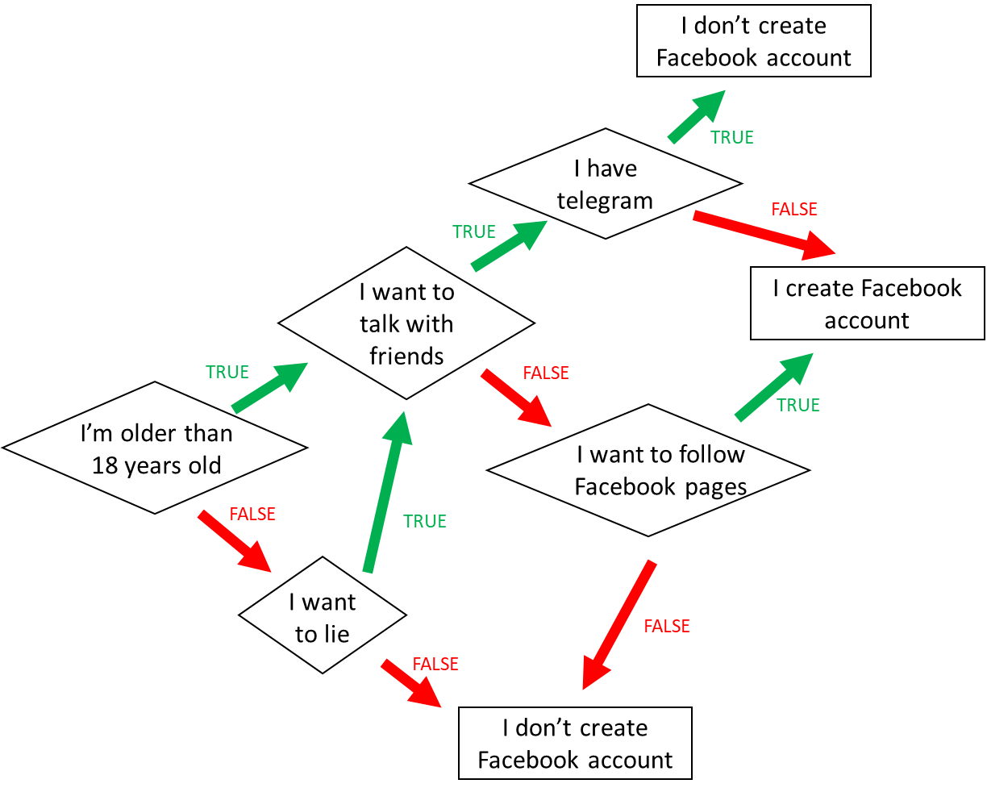

1. When do I create a Facebook account? (*Express the condition using a Boolean expression)*

|  |
| --- |
| (I’m older than 18 year old and I want to talk with talk with friends and I have not telegram) or (I’m not older than 18 years old and I want to lie and I want to talk with friends and I have telegram) or (I’m older than 18 years old and I won to talk with friends and I want to follow facebook pages) or (I’m not older than 18 years old and I want to lie and I won to talk with friends and I want to follow facebook pages) |

1. When **don’t I** create a Facebook account? *(Express the condition using a Boolean expression)*

|  |
| --- |
| (I’m not older than 18 years old and I won to lie) or (I’m not older than 18 years old and I want to lie and I want to talk with friends and I have telegram) or (I’m not older than 18 years old and I want to lie and I won to talk with friends and I won to follow facebook page) or (I’m older than 18 years old and I won to talk with friends and I won to follow facebook page) |

Ex5: Create the chart flow

**Q1** Complete the char flow to follow those rules:

* If I am a girl and it is sunny, I wear a skirt
* If I am a girl and it is not sunny, I wear jeans
* If I am a boy and it is sunny, I wear a short
* If I am a boy and it is not sunny, I wear jeans

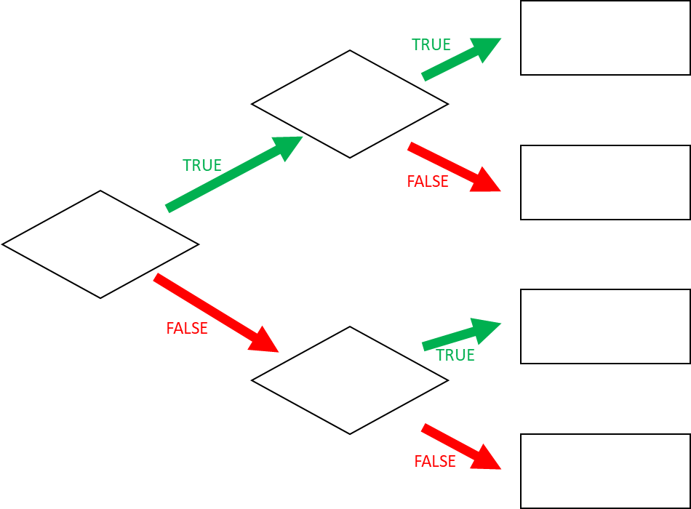

Wear a jeans

Wear a skirt

Wear a jeans

Wear a short

Sunny

Sunny

Boy

**Q1** When do I wear jeans? *(Express the condition using a Boolean expression)*

I wear jeans if:

|  |
| --- |
| -Boy and not sunny, I wear a jeans  -girl and sunny, I wear a jeans.  -Boy and sunny, I wear a short.  -Girl and not sunny, I wear a skirt. |